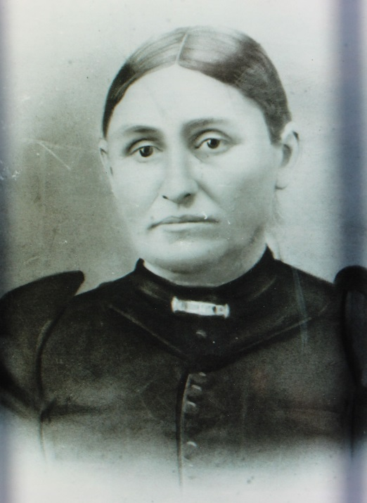

Lena Armbrust Kern, mother of Maggie Kern

and grandmother of Luther J. List – about 1905 (est.)

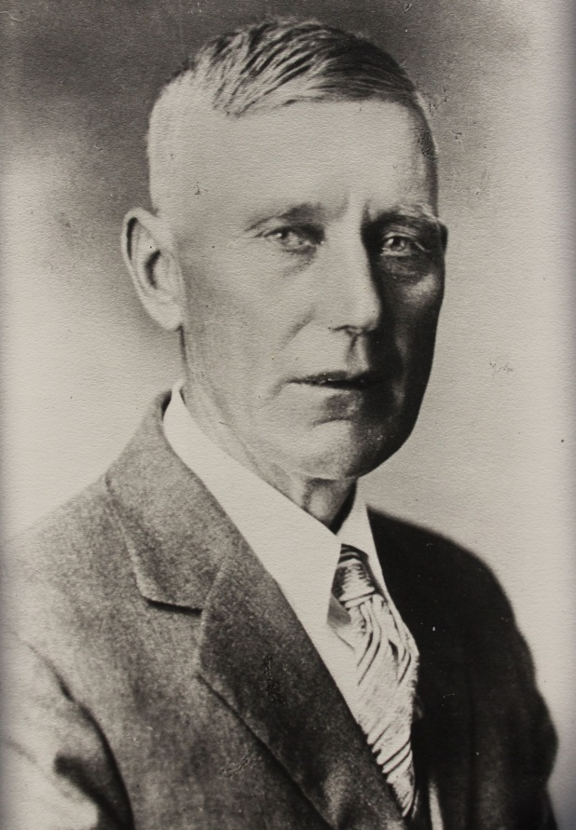

John Adam List – father of Luther J. List – about 1920 (est.)